CAS PY 106

Prelecture Note 30

1. The interference of light
2. In 1801, Thomas Young carried out a famous experiment that showed very clearly that light acted as a wave
3. Producing a stable interference pattern
4. To produce a stable and clear interference pattern from two sources, the sources should be coherent (maintaining a fixed phase relationship) and monochromatic (having a single wavelength)
5. Interference from two sources
6. Sound wave patterns that are emitted by two speakers one at a time
7. 
8. 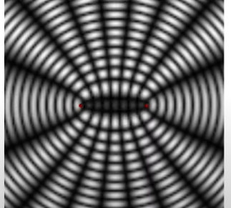
9. Two sources broadcasting identical waves create an interference pattern with bands of constructive and destructive interference
10. The sources are in phase – emit peaks at the same time
11. What happens at any point depends on the path length difference, delta L, the distance from one source to the point minus the distance from the other source to the point
12. Interference in 2-D
13. When the two sources are in-phase you will always get constructive interference along the perpendicular bisector of the line joining the sources
14. This is because the path length difference for any point on the perpendicular bisector is an integer number of wavelengths
15. Interference from two sources
16. Condition for constructive interference: path-length difference is L = m \* lambda, where m is any integer
17. Condition for destructive interference: path-length difference is L = (m + ½) \* lambda, where m is any integer
18. Understanding the interference pattern
19. Two source positions are shown in red
20. The waves spread out as rings from the sources, red for peaks and blue for troughs
21. 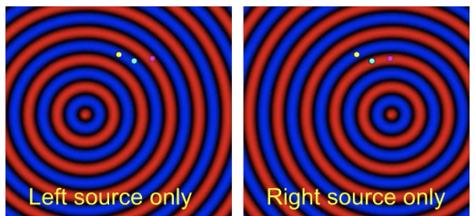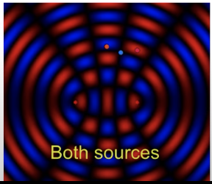
22. At any point on the perpendicular bisector to the line joining the sources we et constructive interference – the path-length distance is zero
23. 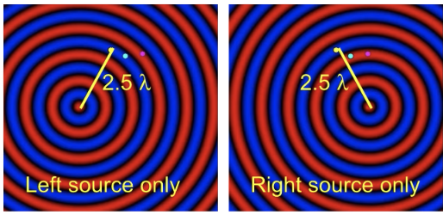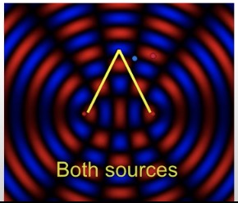
24. The blue point is half a wavelength farther from the left source than from the right source – giving destructive interference at that point
25. 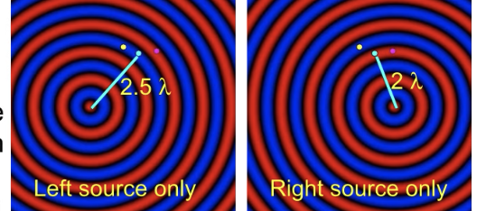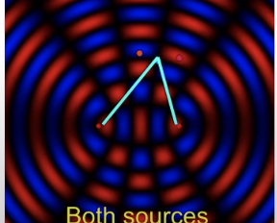
26. The purple point is a full wavelength farther from the left source than from the right source – giving constructive interference at that point
27. 